**Cancer Prediction Application**

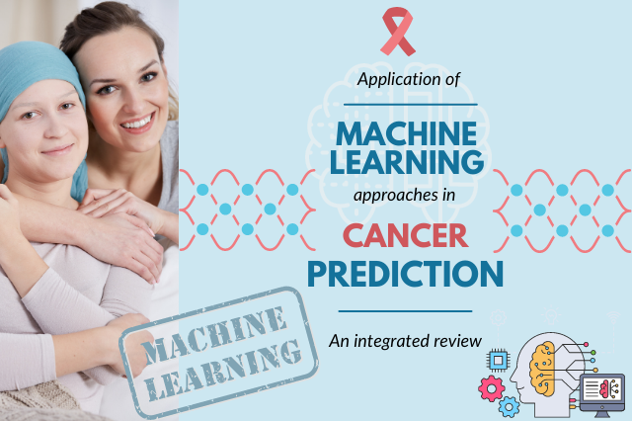

Team Members:-

Jaswanth Sunkara

Madhavendra Singh

Siva Sri Harsha Pulipati

Prabhanshu Singh

**Abstract**

In the realm of modern healthcare, medical imaging stands as a crucial pillar for the early detection and diagnosis of diseases, notably breast cancer. This abstract introduces a groundbreaking medical imaging prediction app, engineered to harness artificial intelligence and machine learning for unparalleled diagnostic precision and efficiency, with a specific focus on breast cancer prediction.

This innovative application offers a multitude of critical capabilities. Utilizing state-of-the-art deep learning algorithms, the app conducts intricate analyses of medical images, including mammograms and breast ultrasounds. It can identify subtle anomalies and intricate patterns that may elude human observation, enhancing early breast cancer detection.

With remarkable speed, the app generates real-time predictions and probability assessments specific to breast cancer. This empowers healthcare professionals with timely and informed insights, assisting in the diagnosis and treatment planning process.

The user-friendly interface is designed to accommodate healthcare professionals of varying technological proficiencies, ensuring seamless integration into existing clinical workflows. In addition to prediction, the app serves as a valuable interpretative companion. It provides insights and references pertinent medical literature, bolstering the decision-making capabilities of healthcare providers.

The app prioritizes the privacy of patient data and adheres rigorously to healthcare regulations, safeguarding sensitive medical information. Designed for ongoing improvement, the app regularly updates its machine learning models with the latest breast cancer research findings and medical data, enhancing accuracy and predictive capabilities.

The app seamlessly integrates with hospital and healthcare management systems, simplifying patient data management and retrieval for more efficient breast cancer diagnosis and treatment.

This Medical Imaging Prediction App for Breast Cancer stands at the forefront of medical diagnostics. By arming healthcare professionals with advanced tools for breast cancer prediction and early detection, it heralds a new era in breast cancer management and care. The result is an elevated standard of patient care, improved healthcare outcomes, and renewed hope for individuals facing breast cancer worldwide. This abstract provides a glimpse into the transformative potential of AI-driven healthcare solutions, specifically tailored to breast cancer prediction and diagnosis.

**Problem Statement**

The challenge lies in accurately predicting breast cancer outcomes using advanced predictive modelling techniques to aid in early detection and improve patient outcomes. Despite the critical importance of early diagnosis and the availability of cutting-edge medical imaging technology, healthcare professionals often face the daunting task of interpreting complex medical images and predicting breast cancer with the highest level of accuracy. Existing tools and methodologies fall short in providing the necessary precision required for early intervention. Consequently, there is an urgent need for a sophisticated medical imaging prediction app, specifically tailored to breast cancer, that leverages artificial intelligence and machine learning to enhance diagnostic accuracy and streamline the decision-making process for healthcare providers. This problem statement highlights the critical need for a comprehensive solution that can revolutionize breast cancer detection and ultimately contribute to improved patient care and outcomes.

**Market/Customer Need Assessment**

Breast cancer stands as a profound global health challenge, with its prevalence affecting millions of lives annually. In the fight against this disease, early detection emerges as a pivotal factor that can significantly impact survival rates and the effectiveness of treatment regimens. Recognizing the critical role of early diagnosis, there is a pressing demand for advanced and dependable breast cancer prediction tools that can empower healthcare professionals in their efforts to identify high-risk individuals and instigate timely interventions.

Existing screening methods, while valuable, exhibit inherent limitations that hinder their ability to provide the level of accuracy and personalization demanded by modern healthcare standards. The evolving landscape of healthcare calls for predictive models that can harness the richness of diverse patient data, spanning from medical imaging to clinical history, genetics, and lifestyle factors. By addressing this compelling need, healthcare providers stand to unlock a myriad of benefits that extend far beyond the realm of diagnosis.

**1. Enhanced Patient Care:** The advent of more sophisticated predictive models means that healthcare professionals can offer their patients a higher level of personalized care. Such models can aid in identifying individuals with a predisposition to breast cancer and facilitate tailored screening schedules, early detection, and tailored treatment plans. This not only improves the quality of care but also fosters greater patient engagement and satisfaction.

**2. Resource Optimization:** With the ability to pinpoint high-risk individuals more accurately, healthcare institutions can optimize the allocation of their resources. This includes targeted screening efforts, efficient utilization of medical imaging resources, and a more judicious allocation of medical personnel, ultimately leading to cost savings and improved resource management.

**3. Societal Impact:** Beyond the immediate healthcare realm, addressing the demand for advanced breast cancer prediction tools holds the potential to reduce the societal burden of breast cancer. Timely interventions, early detection, and optimized treatment pathways can translate into lower healthcare costs, reduced productivity losses, and a significant reduction in the emotional toll borne by patients and their families.

In summary, the market and customer need assessment reveal a clear imperative for advanced predictive models tailored to breast cancer prediction. By leveraging diverse patient data, these models can empower healthcare providers to enhance patient care, optimize resource allocation, and contribute to the broader goal of alleviating the burden of breast cancer on individuals and society as a whole. The pursuit of such solutions aligns closely with the evolving standards of healthcare excellence and underscores the urgency of addressing this critical need in the fight against breast cancer.

**Target Specification and Characterization**

**Target Specification**

The primary objective of this breast cancer prediction product is to conceive and develop an exceptionally robust and precise predictive model. This model's paramount purpose is to discern individuals who harbour a heightened risk of breast cancer development. To achieve this, the model will ingeniously harness a diverse array of patient-specific characteristics, encompassing demographic information, medical history, genetic predispositions, and a comprehensive suite of medical imaging data. The ultimate aim is to craft a model that yields personalized risk assessments of unparalleled accuracy.

By deftly pinpointing individuals at elevated risk, healthcare providers will gain invaluable insights, facilitating the delivery of meticulously focused screening protocols and preemptive interventions. The overarching goal is to improve patient outcomes, mitigate the devastating impact of breast cancer, and in doing so, contribute significantly to the reduction of the overall burden posed by this formidable disease.

**Target Characterization**

The target population for this breast cancer prediction endeavor encompasses a diverse spectrum of individuals, spanning various age groups, genders, and ethnic backgrounds, all of whom are susceptible to the potential emergence of breast cancer. The model aspires to cast a wide net, identifying those within this heterogeneous demographic tapestry who harbor an augmented likelihood of developing the disease.

Through the adept amalgamation of exhaustive data analysis and cutting-edge machine learning techniques, the model will orchestrate a symphony of insight. Its harmonious objective is to unfurl personalized risk assessments that transcend conventional one-size-fits-all approaches. These risk assessments, as fine-tuned as a surgeon's scalpel, will serve as the guiding light for healthcare professionals. Armed with this data-driven wisdom, they will chart courses of action, rendering informed decisions that cater to the individualized needs of each and every patient.

In summary, the target specification and characterization for this breast cancer prediction initiative are resolutely focused on precision and personalization. It is a collective endeavor that spans demographics and backgrounds, dedicated to the noble mission of early detection, effective intervention, and, ultimately, the alleviation of the profound impact of breast cancer on individuals and society as a whole.

**Business Scheme**

The inception of this breast cancer prediction product is anchored in meticulous market analysis and research. This includes assessing the evolving demand for advanced predictive tools in the dynamic healthcare sector, understanding the competitive landscape, and pinpointing market gaps. A cross-functional team, drawing expertise from data scientists, machine learning specialists, healthcare professionals, and software developers, will converge to spearhead the product's development. An indispensable facet of this endeavor involves securing robust data sources through partnerships with healthcare institutions, underpinned by unwavering commitment to stringent data privacy regulations like HIPAA.

User experience takes center stage, driving the design of an intuitive and user-friendly interface that simplifies data input and result retrieval for healthcare professionals. Simultaneously, a highly adaptable machine learning infrastructure will be established, capable of processing large-scale data sets efficiently. Continuous model updates will be an ongoing pursuit to enhance predictive accuracy.

Compliance with regulatory requirements, including the potential need for FDA approval and other certifications, will be a top priority. The choice of a revenue model is strategic, ranging from subscription fees for healthcare institutions to licensing agreements or per-prediction charges, with the possibility of offering a limited free trial period for initial users. A dedicated marketing strategy will be devised, leveraging content marketing, participation in industry conferences, and strategic partnerships with healthcare organizations to promote the product's adoption.

User training and comprehensive support will be provided, ensuring healthcare professionals are adept at utilizing the predictive model effectively. To maintain the highest standards of data security, substantial investments will be made in stringent data protection measures, including encryption and access controls.

Continuous improvement is integral, driven by feedback mechanisms that solicit user insights and technical refinements. Sustainability and scalability will be etched into the long-term strategy, with a keen eye on managing operational costs and diversifying revenue streams. As part of this expansion, strategic partnerships with healthcare institutions, insurance companies, and research organizations will be pursued to broaden both the product's reach and data sources for further model enhancement.

Key performance indicators (KPIs) will be instituted to systematically gauge the product's impact on breast cancer detection rates, patient outcomes, and healthcare cost savings. Additionally, monitoring and evaluation processes will provide valuable insights into the product's efficacy, facilitating timely adjustments and improvements.

In essence, this comprehensive business scheme reflects a resolute commitment to conceiving, developing, deploying, and sustaining a breast cancer prediction product that addresses the complex challenges of healthcare, thereby improving patient outcomes and reducing the global burden of breast cancer.

**Monetization Strategies for a Breast Cancer Prediction App**

1. **Subscription Model for Healthcare Institutions:** One of the primary revenue streams for our breast cancer prediction app is the subscription model, tailored for hospitals, clinics, and healthcare institutions. By subscribing, these organizations gain continuous access to our cutting-edge predictive capabilities, enabling them to enhance their diagnostic processes and patient care. The subscription fee can be customized based on factors such as the number of users and the volume of predictions required.
2. **Licensing Fees:** We offer licensing arrangements for those seeking to integrate our breast cancer prediction software into their existing healthcare solutions. Whether it's healthcare providers, research institutions, or medical technology companies, our licensing options cater to diverse needs. Licensing fees can be structured as one-time payments, annual renewals, or based on usage metrics.
3. **Pay-per-Prediction Model:** For smaller healthcare practices and individual healthcare professionals, our pay-per-prediction pricing model ensures cost-effectiveness. Users pay a fee for each breast cancer risk assessment generated by our app, allowing them to pay only for the predictions they need, with no commitment to ongoing subscriptions.
4. **Tiered Pricing:** To accommodate a broad range of users with varying needs and budgets, we offer tiered pricing. Users can choose from different packages based on the features and capabilities they require. This approach provides flexibility and scalability, ensuring that users can access the level of functionality that suits their practice best.
5. **Freemium Model:** Our freemium model enables users to access a basic version of our breast cancer prediction app for free. This version offers essential features and a limited number of predictions. Users can upgrade to a premium version, which unlocks advanced capabilities and unlimited predictions, available through a subscription fee.
6. **Data Licensing:** Leveraging the data generated by our app, we offer data licensing opportunities. Aggregating and anonymizing user data, we make it available for pharmaceutical companies, research institutions, and healthcare analytics firms. These entities can use this data for research purposes, creating a new revenue stream for our app.
7. **Consultation and Training Services:** In addition to our software offerings, we provide consultation and training services. Healthcare institutions and professionals can benefit from on-site training, workshops, and personalized consultations to maximize the use of our predictive model, with fees associated with these value-added services.
8. **Custom Development:** Tailoring our app to meet specific needs, we offer custom development services. Healthcare organizations looking for customized solutions, integrations, or unique features can enlist our expertise for a fee, ensuring our app seamlessly fits into their workflow.
9. **API Access:** For other healthcare software developers and institutions seeking to leverage our predictive model, we provide API access. This allows them to integrate our technology into their own applications or systems, with licensing fees or usage fees associated with API access.
10. **Research Partnerships:** Our app fosters research collaborations with institutions and pharmaceutical companies, focusing on breast cancer prediction and personalized medicine. Revenue streams may include research grants, partnerships, or licensing agreements for proprietary algorithms or data.
11. **Telemedicine Integration:** Through partnerships with telemedicine platforms, our app can be seamlessly integrated into their services, expanding their diagnostic capabilities. Telemedicine providers may pay fees to access our predictive features, enhancing the suite of diagnostic tools they offer.

These diverse monetization strategies reflect our commitment to offering a range of options for healthcare professionals and organizations to access our breast cancer prediction app, ensuring affordability, customization, and value across the healthcare spectrum.

External Search

**1. Dataset:** The primary dataset used for training and evaluation was obtained from Kaggle ( www.kaggle.com ). The specific dataset used can be found at Breast Cancer Wisconsin (Diagnostic) Data Set | Kaggle.

**2. Research Papers and Journals:** Various scientific research papers and journals were consulted to gain insights into breast cancer prediction methods, feature selection techniques, machine learning algorithms, and evaluation metrics. Some notable sources include:

* (PDF) BREAST CANCER PREDICTION USING MACHINE LEARNING (researchgate.net)
* A Comparative Analysis of Breast Cancer Detection and Diagnosis Using Data Visualization and Machine Learning Applications - PMC (nih.gov)

**Prototype Development**

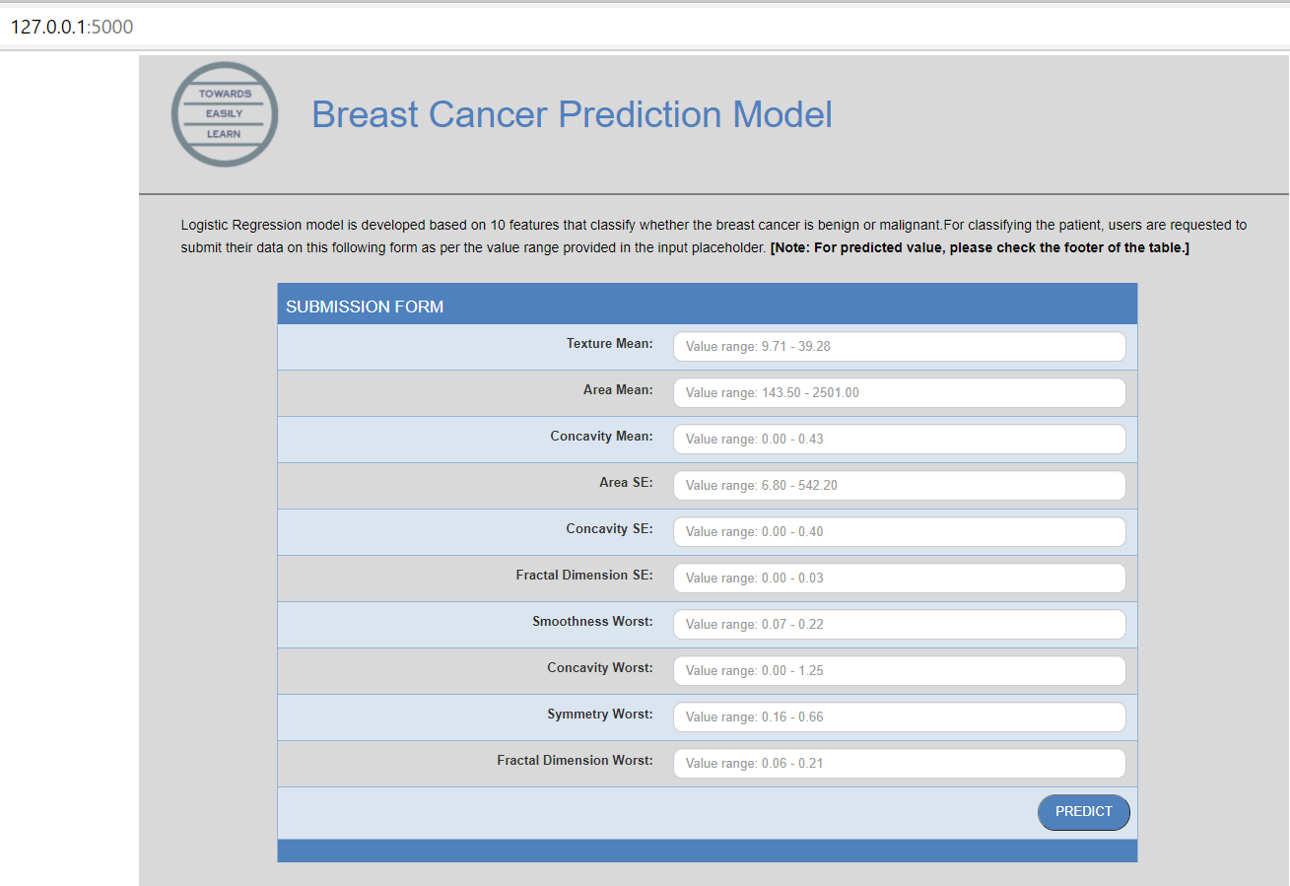

**Business Model**

**1. Value Proposition:**

* **Advanced Breast Cancer Prediction:** Our app stands at the forefront of breast cancer prediction, leveraging cutting-edge artificial intelligence and machine learning techniques to deliver unparalleled accuracy. It excels in identifying individuals at high risk of developing breast cancer, revolutionizing early detection.
* **Personalized Risk Assessment:** We take personalization to the next level. Our app harnesses a vast array of patient data, including medical history, genetic markers, demographics, and advanced medical imaging, to craft highly customized risk assessments tailored to each patient's unique profile.
* **Improved Patient Outcomes:** Beyond mere predictions, our app translates into tangible improvements in patient care. By enabling the identification of high-risk individuals early on, it empowers healthcare providers to initiate timely interventions, leading to better treatment outcomes and a significant reduction in the societal burden of breast cancer.

**2. Customer Segments:**

* **Healthcare Institutions:** Hospitals, clinics, and healthcare organizations are pivotal customers. They seek our app's capabilities to enhance their breast cancer diagnosis and treatment protocols.
* **Healthcare Professionals:** Oncologists, radiologists, and general practitioners are key users who rely on our app's predictive insights to make informed decisions about screening, prevention, and treatment.
* **Research Institutions:** Organizations engaged in breast cancer research and clinical trials find immense value in our app's predictive capabilities, aiding their research objectives.
* **Pharmaceutical Companies:** We offer pharmaceutical firms invaluable data for drug development, clinical trials, and research into breast cancer treatments.
* **Telemedicine Platforms:** Our app can seamlessly integrate into telemedicine platforms, bolstering their diagnostic toolkit and expanding their service offerings.

**3. Channels:**

* **Direct Sales:** Our dedicated sales team establishes direct relationships with healthcare institutions and professionals, offering tailored solutions and personalized support.
* **Online Platforms:** A professional website serves as a central hub for product information, demonstrations, and online sales. It's a convenient access point for users looking to explore our app's capabilities.
* **Partnerships:** Collaborative partnerships with telemedicine platforms, research institutions, and pharmaceutical companies extend our reach and facilitate the integration of our predictive model into diverse healthcare ecosystems.
* **Industry Conferences:** Participation in prominent healthcare conferences and exhibitions serves as a platform to showcase our app's capabilities, engage with potential clients, and stay at the forefront of industry developments.
* **Content Marketing:** Regularly produced informative content, including blog posts and whitepapers, establishes us as thought leaders in breast cancer prediction and attracts potential customers through educational resources.

**4. Customer Relationships:**

* **Consultation and Training:** Our commitment to customer success extends to consultation and training services. We ensure that healthcare professionals are not only proficient in using our app but also confident in its capabilities.
* **Customer Support:** Responsive customer support is a cornerstone of our service. We address inquiries, technical issues, and provide guidance promptly, ensuring that users have a seamless experience.
* **Feedback Loop:** We actively engage with our user community, establishing mechanisms for collecting feedback. This user-centric approach drives continuous improvement, refining both our predictive model and user interface based on user insights.

**5. Revenue Streams:**

* **Subscription Fees:** Our primary revenue stream originates from subscription plans tailored for healthcare institutions. Pricing tiers are based on factors such as the number of users, prediction volume, and the level of support provided.
* **Licensing Fees:** Licensing agreements serve as a revenue generator, particularly for healthcare providers, research institutions, and medical technology companies that seek to integrate our predictive model into their systems.
* **Pay-per-Prediction:** Individual healthcare professionals can access our app on a pay-per-prediction basis. This flexible model charges users based on the specific number of risk assessments they require, accommodating varying needs.
* **Data Licensing:** Monetizing anonymized and aggregated user data represents a revenue opportunity. Pharmaceutical companies, research institutions, and healthcare analytics firms can access this data for research purposes.
* **Custom Development Services:** We offer revenue-generating custom development and integration services, tailoring our app to meet the unique requirements of healthcare organizations.
* **API Access Fees:** We charge fees for API access, allowing other healthcare software developers and institutions to integrate our predictive model into their applications, creating an additional income stream.

**6. Key Resources:**

* **Data Scientists and Machine Learning Experts:** Our core team includes seasoned data scientists and machine learning experts responsible for the development, optimization, and continuous refinement of our predictive model.
* **Healthcare Professionals:** Medical experts within our team validate predictions and provide crucial guidance to ensure that our app remains clinically relevant and aligned with best practices.
* **Software Developers:** A skilled development team is essential for building and maintaining the app, ensuring its robustness and reliability.
* **Data Sources:** Access to comprehensive and diverse medical data sources is pivotal. These data sources fuel our model's training and validation.
* **Regulatory Expertise:** Regulatory experts play a vital role in navigating the complex healthcare regulatory landscape, ensuring that our app complies with all necessary regulations and standards.

**7. Key Activities:**

* **Model Development:** Our team is continuously engaged in the development and refinement of our predictive model. This ongoing effort is central to improving prediction accuracy and clinical relevance.
* **Data Acquisition:** Establishing partnerships and securing access to diverse and high-quality patient data is an ongoing key activity. Strict adherence to data privacy regulations is paramount.
* **User Training:** We provide comprehensive training to healthcare professionals to ensure they can effectively utilize our app to its full potential.
* **Customer Support:** Offering responsive customer support is a critical ongoing activity, ensuring that user inquiries, technical issues, and guidance requests are addressed promptly.
* **Marketing and Sales:** Promotion of our app is an ongoing effort encompassing marketing campaigns, direct sales efforts, and participation in industry events.

**8. Key Partnerships:**

* **Healthcare Institutions:** Collaborative partnerships with hospitals and clinics are fundamental. These partnerships facilitate access to patient data and the provision of our predictive services within healthcare settings.
* **Telemedicine Platforms:** Partnerships with telemedicine platforms extend our reach and enable the seamless integration of our predictive model into telemedicine services, enhancing their diagnostic capabilities.
* **Pharmaceutical Companies:** Partnerships with pharmaceutical companies create opportunities for research collaborations and data licensing agreements, contributing to mutual research and development objectives.
* **Research Institutions:** Collaborations with research institutions enable joint efforts in breast cancer research, clinical trials, and the advancement of predictive techniques.

**9. Cost Structure:**

* **Personnel Costs:** These include salaries for data scientists, machine learning experts, software developers, and sales teams, who are integral to our operations.
* **Data Acquisition Costs:** Expenses related to the acquisition of diverse and high-quality patient data sources.
* **Regulatory Compliance:** Costs associated with regulatory experts and compliance efforts to ensure adherence to healthcare regulations.
* **Customer Support and Training:** Resources allocated for the provision of customer support and training services.
* **Marketing and Sales:** Expenditures for marketing campaigns, direct sales efforts, and industry event participation.
* **Infrastructure Costs:** Expenses linked to server hosting, maintenance, and IT infrastructure.
* **Research and Development:** Investment in ongoing research and development activities, including model enhancement and optimization.

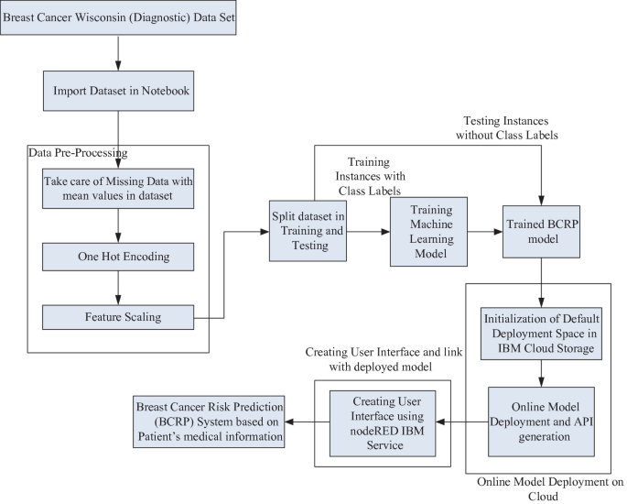

**Subscription Model**

The most suitable business model for a breast cancer prediction app is the Subscription Model. This choice is driven by several key factors that make it the optimal fit for the unique requirements of such an application. Firstly, breast cancer prediction is an ongoing process that relies on the availability of the latest medical data and cutting-edge predictive algorithms. A subscription model provides the necessary sustainability by generating consistent and predictable revenue. This financial stability, in turn, allows for continuous app development and improvement, ensuring that it remains at the forefront of breast cancer prediction technology.

Moreover, the Subscription Model fosters long-term engagement with healthcare institutions and professionals who subscribe to the service. It establishes a committed user base that relies on the app for accurate risk assessments and early detection, ultimately contributing to better patient outcomes. The ongoing relationship with subscribers enables the app to adapt to evolving needs and stay aligned with the latest advancements in breast cancer research and treatment.

Flexibility is another key advantage of the Subscription Model. Different tiers of subscription plans can be tailored to cater to the diverse needs of various customer segments, including hospitals, clinics, and individual healthcare professionals. This customization ensures that users have access to the specific features and predictive capabilities that best suit their practice, promoting user satisfaction and retention.

Furthermore, as the app accumulates a wealth of anonymized and aggregated user data over time, it opens up opportunities for data monetization. This valuable dataset can be made available for research purposes, creating an additional revenue stream through data licensing agreements with pharmaceutical companies, research institutions, and healthcare analytics firms.

In summary, the Subscription Model stands out as the ideal choice for a breast cancer prediction app due to its sustainability, long-term engagement, predictability, flexibility, and potential for data monetization. It not only ensures the continuous development and improvement of the app but also aligns with the overarching goal of making accurate breast cancer risk assessments widely accessible, thereby contributing to early detection and improved patient outcomes.

**Financial Modelling**  
  
The following equation gives a basic outlook into how revenue can be predicted.

**Annual Revenue (AR) = Number of Subscribers (N) x Average Annual Subscription Price (ASP)**

However more factors need to be taken into consideration while performing this analysis. These factors include:

* **Customer Growth Rate (G)**: The rate at which your subscriber base is expected to grow over time. This can be expressed as a percentage, e.g., 10% growth per year.
* **Churn Rate (C)**: The percentage of subscribers who cancel their subscriptions each year. Subtracting this from the growth rate gives you the net subscriber growth.
* **Pricing Tiers**: If you offer different subscription tiers (e.g., basic, standard, premium), you'd need to calculate the Average Annual Subscription Price (ASP) for each tier and factor in the percentage of subscribers in each tier.
* **Customer Acquisition Cost (CAC)**: The cost associated with acquiring a new subscriber. This can include marketing expenses, sales team salaries, and other costs.
* **Operating Expenses (OPEX)**: Costs related to running and maintaining the application, including server hosting, personnel, customer support, and marketing.
* **Retention Rate (R)**: The percentage of subscribers who continue their subscriptions each year. You can calculate it as (1 - Churn Rate).

The equation can then be modified as such in order to account for the rest of these factors.

**Annual Revenue (AR) = [N x ASP x R] - [CAC x N] - OPEX**

This equation factors in the revenue generated by retaining subscribers (taking into account the churn rate and pricing tiers), subtracts the cost of acquiring new customers, and deducts operating expenses.

**Conclusion**

In conclusion, the development and implementation of a breast cancer prediction application present a profound opportunity to address a critical global health concern. By leveraging advanced predictive modelling techniques and a subscription-based business model, we can make significant strides in improving early detection, patient outcomes, and ultimately reducing the burden of breast cancer on individuals and society.

The choice of a subscription-based model is well-founded, offering sustainability, long-term engagement, predictability, flexibility, and the potential for data monetization. It ensures ongoing access to cutting-edge breast cancer prediction capabilities and personalized risk assessments, while accommodating the needs of various customer segments, from healthcare institutions to individual practitioners.

Furthermore, the financial model, though simplified here, underscores the importance of considering key factors such as customer growth, churn rates, pricing tiers, customer acquisition costs, and operating expenses when projecting revenue. A comprehensive financial model provides the foundation for strategic planning and sustainable growth.

Overall, the breast cancer prediction application represents a significant advancement in healthcare technology, with the potential to positively impact countless lives. As it continues to evolve, refine its predictive algorithms, and expand its user base, it stands at the forefront of early detection and improved patient care in the fight against breast cancer.